Table of Contents
Activity 1: Concept Review Questions 2
1. Key Components of Transaction Management 2
Atomicity 2
Consistency 2
Isolation 2
Durability 2
The Importance of Transaction Management 2
2. Challenges Associated with Concurrency Control in Database Systems 3
3. How Database Security Mechanisms Protect Sensitive Data 3
User Authentication 3
Authorization and Access Control 3
Encryption 3
Backups and Recovery 4
Logging and Auditing 4
Importance of Database Security 4
Activity 2: Practical Implementation of Transactions 4
1. Tools and Software Used 4
2. Database Setup 4
2.1 Creating the Database 4
2.2 Creating Required Tables 5
3. Inserting Sample Records 7
3.1 Customer and Product Data 7
4. Demonstration of ACID Properties 8
4.1 Atomicity 8
4.2 Consistency 10
4.3 Isolation 12
4.4 Durability 13
5. Result Summary 15
Activity 3: Case Study Analysis 15
Challenges Faced 15
Recommended Solutions 16

Activity 1: Concept Review Questions

1. Key Components of Transaction Management
Transaction management is the control of database processes to ensure correct and dependable data. A transaction is a series of database activities, such adding, changing, or removing data, that are managed as a single, coherent entity.
The key components of transaction management are as follows:

Atomicity
An atomic transaction must either be performed entirely or not at all. If any one of the transaction's components fails, the entire transaction is canceled.
For example, funds should not be taken from one bank account while being transferred to another unless they are deposited into the new account as well.

Consistency
To be deemed consistent, a transaction must retain the validity of the database. After the transaction is over, the database rules—such as primary keys, foreign keys, and data types—must still be adhered to.
For example, a student record shouldn't be stored without a student ID if one is required.

Isolation
Isolation states that simultaneous transactions shouldn't interfere with one another. Each transaction should function on its own.
For example, isolation helps prevent inconsistent or erroneous outputs when two users are updating the same data.

Durability
The persistence of modifications made after a transaction is finished is referred to as durability. Even if the system crashes after the transaction is committed, the data should still be available when the database is reopened.

The Importance of Transaction Management
Transaction management is vital because it safeguards the accuracy and dependability of data. It prevents partial updates, prevents data corruption, and preserves the database's dependability. It is extremely significant in systems like banking, online shopping, reservation systems, and student record systems.

2. Challenges Associated with Concurrency Control in Database Systems
Concurrency control is utilized when numerous users or programs access the database at the same time. It ensures that users may engage with the database without producing errors or conflicts.
One of the issues with concurrency control is the lost update problem. One user's edits take precedence over the other's when two users update the same data at the same time.
Another obstacle is dirty reading. A dirty read occurs when a transaction accesses data that has been altered by another transaction but hasn't been stored permanently. If the first transaction is canceled, the second transaction may have used erroneous data.
Another difficulty is deadlock. A deadlock develops when two or more transactions are awaiting the release of locked data. As a result, none of the transactions can be performed.
Concurrency control might potentially reduce performance. Locking records or tables could prevent errors, but the database may slow performance if some users have to wait to access the data.
These issues underline how crucial concurrency control is. Maintaining data accuracy is facilitated when numerous users are concurrently accessing or altering the database.

3. How Database Security Mechanisms Protect Sensitive Data
Database security methods protect sensitive data from loss, damage, misuse, and unlawful access. Sensitive data contains items like passwords, payment details, medical records, student records, and personal information.

User Authentication
Authentication checks a user's identity before providing them access to the database. Usually, usernames and passwords are used for this. Strong authentication makes it possible to assure that only authorized users can log in.

Authorization and Access Control
After a user log in, authorization defines what they can accomplish. For instance, one user might merely be able to view data, whilst another might be able to add, edit, or remove information.
Access control helps keep people from seeing or modifying data that they shouldn't be able to.

Encryption
Encryption turns data into a coded format that is hard for unauthorized persons to read. Encryption makes it difficult for anyone to decipher the data, even if they manage to access it.
Encryption can safeguard data that is being stored in a database and delivered across a network.

Backups and Recovery
Backups protect data by retaining copies of the database. The backup can be used to restore the database in the case that data is lost, overwritten, or destroyed.
This aids in defense against cyberattacks, unintended deletion, and system faults.

Logging and Auditing
User behavior is documented in the database through auditing and logging. This can display who had access to the database, what was altered, and when.
Logs are essential in recognizing strange activity and looking into security risks.

Importance of Database Security
Because it prevents sensitive data from being lost, manipulated, or stolen, database security is vital. It supports enterprises in sustaining user trust and conforming to data protection rules. Private information could be misused or leaked in the lack of proper security.

Activity 2: Practical Implementation of Transactions

1. Tools and Software Used
- WAMP Server
- phpMyAdmin
- MariaDB/MySQL
- Web Browser

2. Database Setup

2.1 Creating the Database
A database named ecommerce_acid_demo was created for the e-commerce transaction practical.
CREATE DATABASE ecommerce_acid_demo;
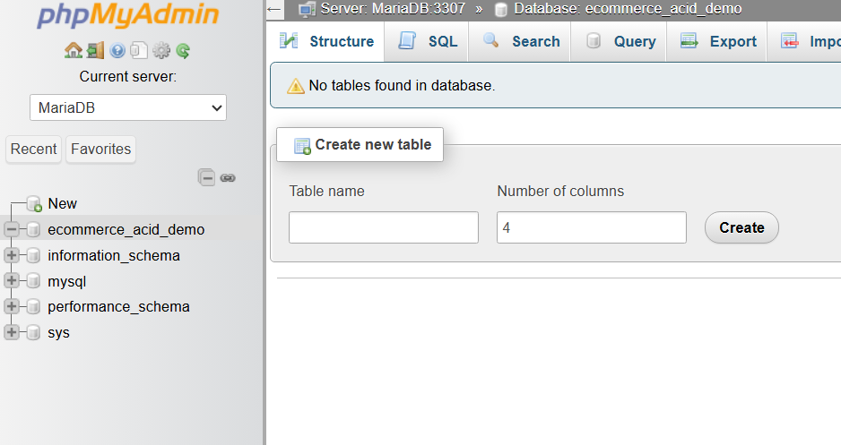

2.2 Creating Required Tables
Four tables were created in the database:
- customers
- products
- orders
- order_items
CREATE TABLE customers (
customer_id INT PRIMARY KEY AUTO_INCREMENT,
customer_name VARCHAR(100) NOT NULL,
email VARCHAR(100) UNIQUE NOT NULL
);

CREATE TABLE products (
product_id INT PRIMARY KEY AUTO_INCREMENT,
product_name VARCHAR(100) NOT NULL,
price DECIMAL(10,2) NOT NULL CHECK (price > 0),
stock INT NOT NULL CHECK (stock >= 0)
);

CREATE TABLE orders (
order_id INT PRIMARY KEY AUTO_INCREMENT,
customer_id INT NOT NULL,
order_date TIMESTAMP DEFAULT CURRENT_TIMESTAMP,
status VARCHAR(20) DEFAULT 'Pending',
FOREIGN KEY (customer_id) REFERENCES customers(customer_id)
);

CREATE TABLE order_items (
order_item_id INT PRIMARY KEY AUTO_INCREMENT,
order_id INT NOT NULL,
product_id INT NOT NULL,
quantity INT NOT NULL CHECK (quantity > 0),
FOREIGN KEY (order_id) REFERENCES orders(order_id),
FOREIGN KEY (product_id) REFERENCES products(product_id)
);

The tables were checked using:
SHOW TABLES;
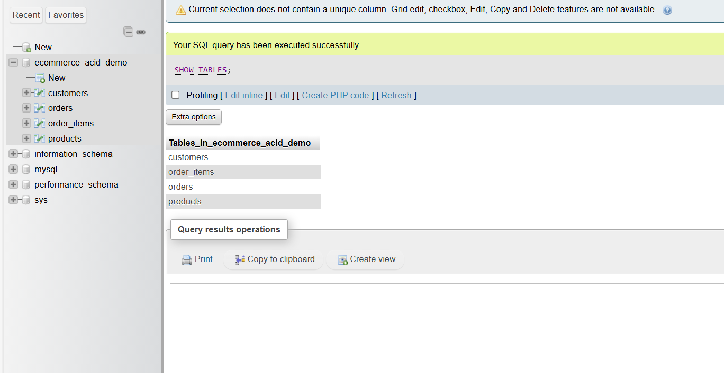

3. Inserting Sample Records

3.1 Customer and Product Data
Sample data was inserted into the customers and products tables.
INSERT INTO customers (customer_name, email)
VALUES
('Ram Thapa', 'ram@example.com'),
('Sita Sharma', 'sita@example.com');

INSERT INTO products (product_name, price, stock)
VALUES
('Laptop', 75000.00, 10),
('Mouse', 1200.00, 50),
('Keyboard', 2500.00, 30);

The inserted records were displayed using:

SELECT * FROM customers;
SELECT * FROM products;
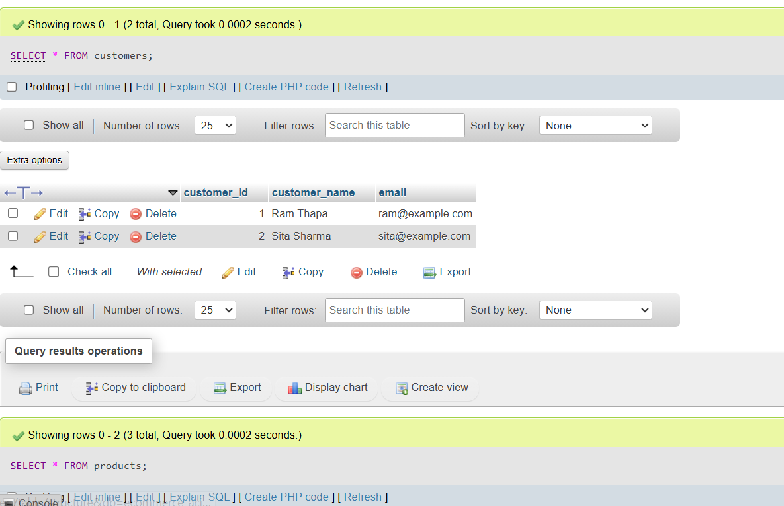

4. Demonstration of ACID Properties

4.1 Atomicity

4.1.1 Transaction Before Rollback
Atomicity means that a transaction is completed fully or not at all. To demonstrate this, a new order and order item were inserted inside a transaction.
START TRANSACTION;

INSERT INTO orders (customer_id, status)
VALUES (1, 'Pending');

INSERT INTO order_items (order_id, product_id, quantity)
VALUES (LAST_INSERT_ID(), 1, 1);

SELECT * FROM orders;
SELECT * FROM order_items;
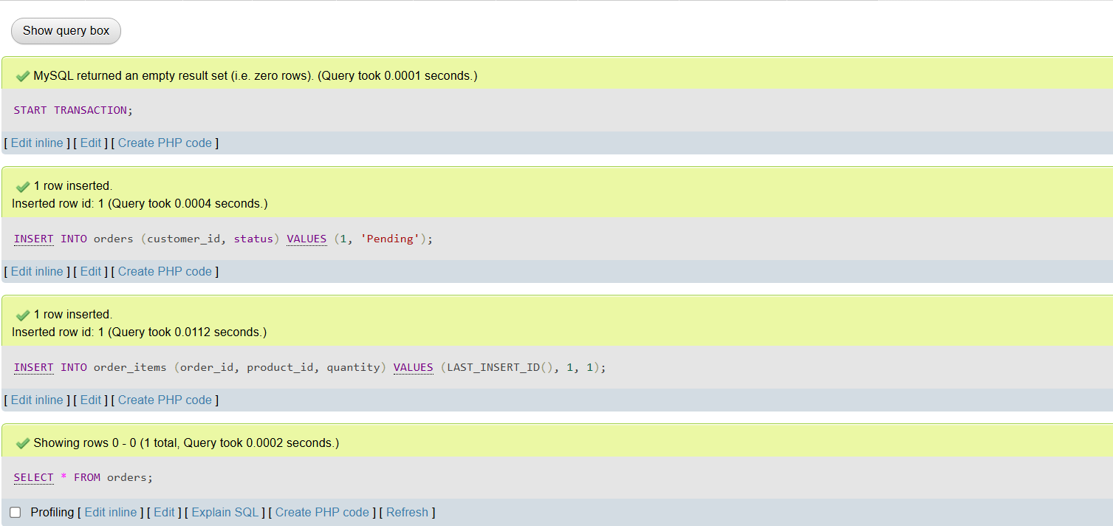

4.1.2 Transaction After Rollback
The transaction was cancelled using the ROLLBACK command.
ROLLBACK;

SELECT * FROM orders;
SELECT * FROM order_items;
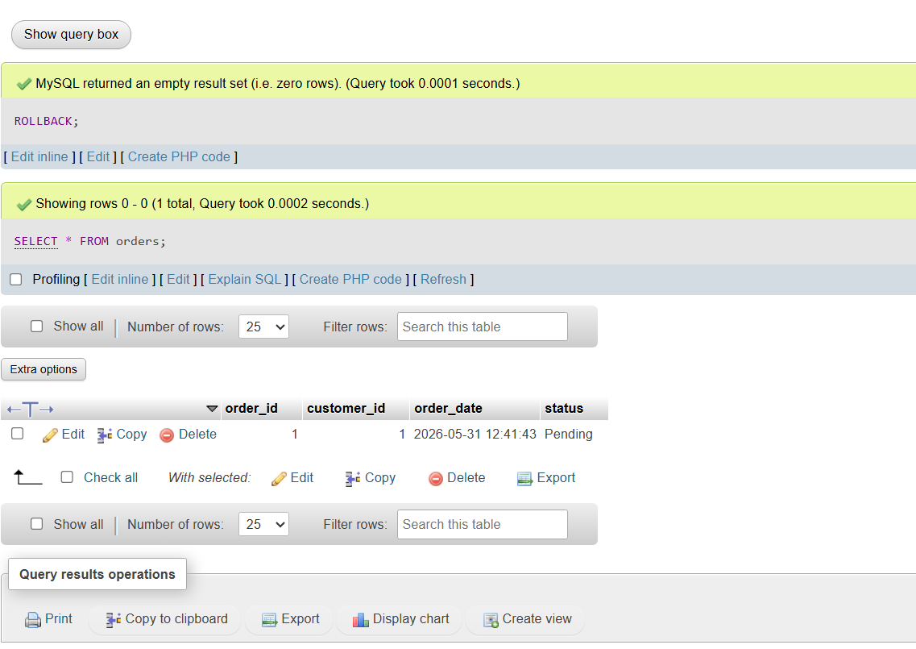
After rollback, the inserted order was not permanently saved. This shows atomicity because the transaction was either completed fully or cancelled fully.

4.2 Consistency

4.2.1 Invalid Product Price
Consistency means the database must always follow defined rules and constraints. An invalid product with a negative price was inserted.
INSERT INTO products (product_name, price, stock)
VALUES ('Invalid Product', -500.00, 10);
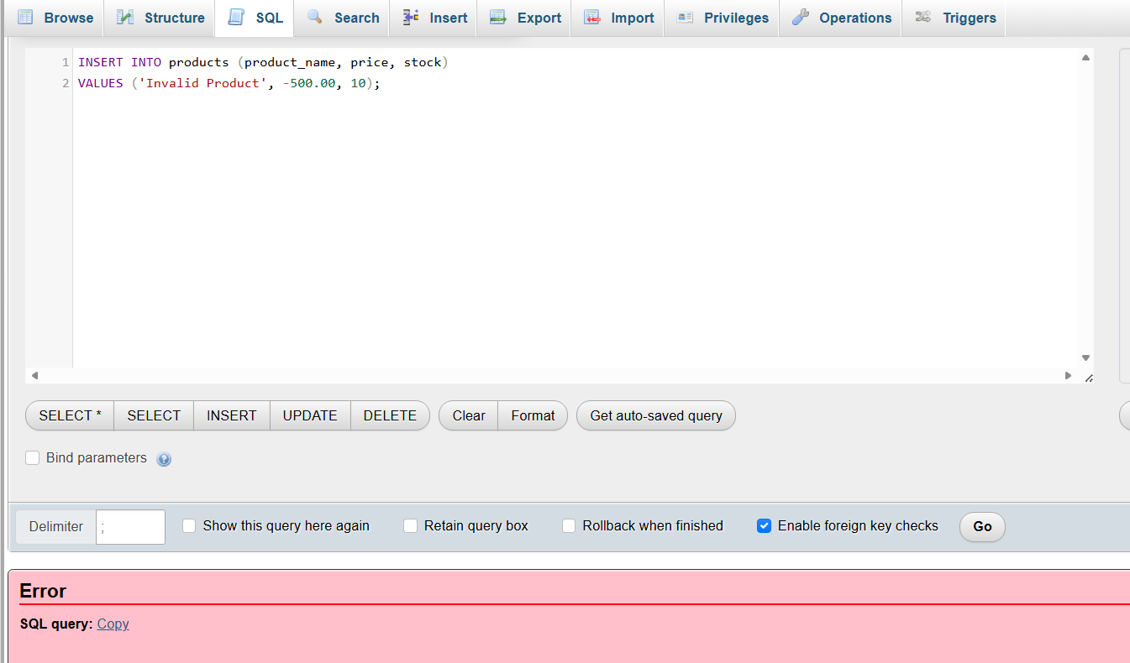
The database rejected the invalid product because the price must be greater than zero.

4.2.2 Invalid Order Quantity
An invalid quantity was inserted into the order_items table.
INSERT INTO order_items (order_id, product_id, quantity)
VALUES (LAST_INSERT_ID(), 1, 0);
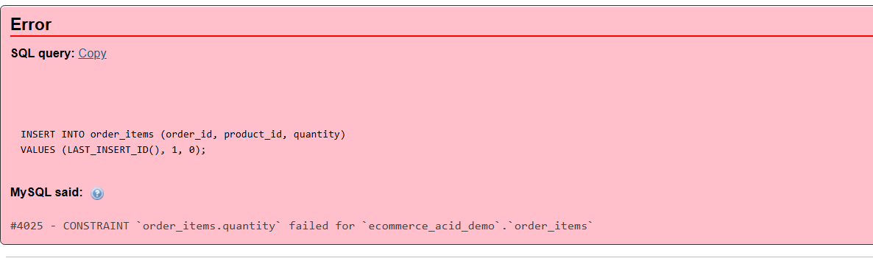
The database rejected the invalid quantity because quantity must be greater than zero. This shows consistency because invalid data was not accepted.

4.3 Isolation

4.3.1 Transaction in First Session
Isolation means one transaction should not interfere with another transaction. In the first phpMyAdmin session, a transaction was started and product stock was updated.
START TRANSACTION;

UPDATE products
SET stock = stock - 1
WHERE product_id = 1;

SELECT * FROM products WHERE product_id = 1;
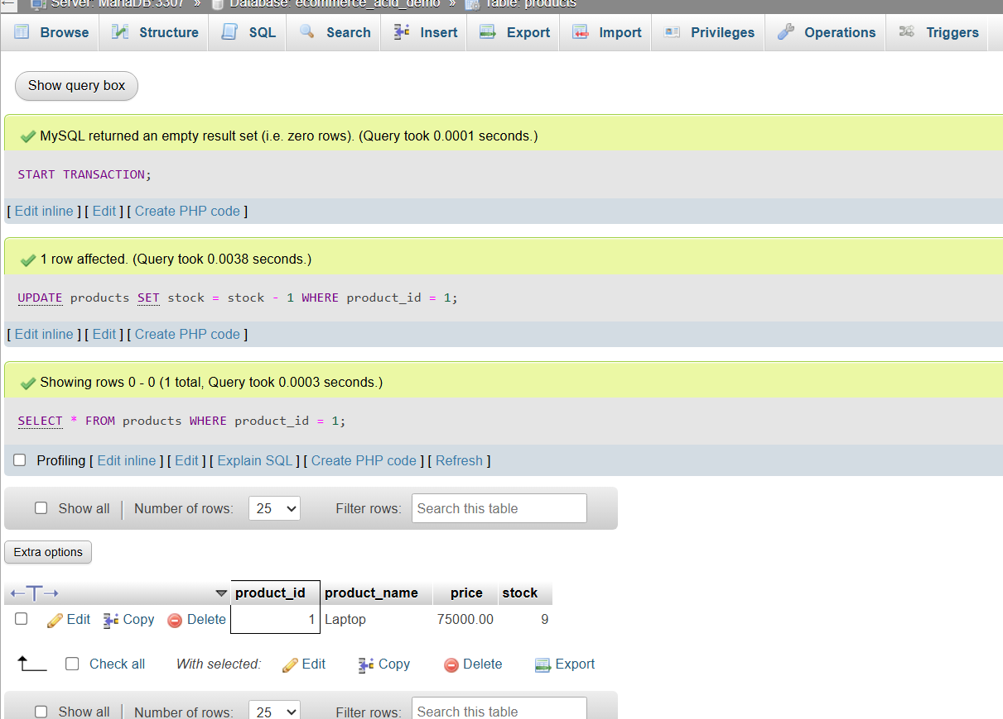

4.3.2 Data After Commit in Another Session
After committing the transaction, the updated product stock was displayed in another session.
COMMIT;

SELECT * FROM products WHERE product_id = 1;
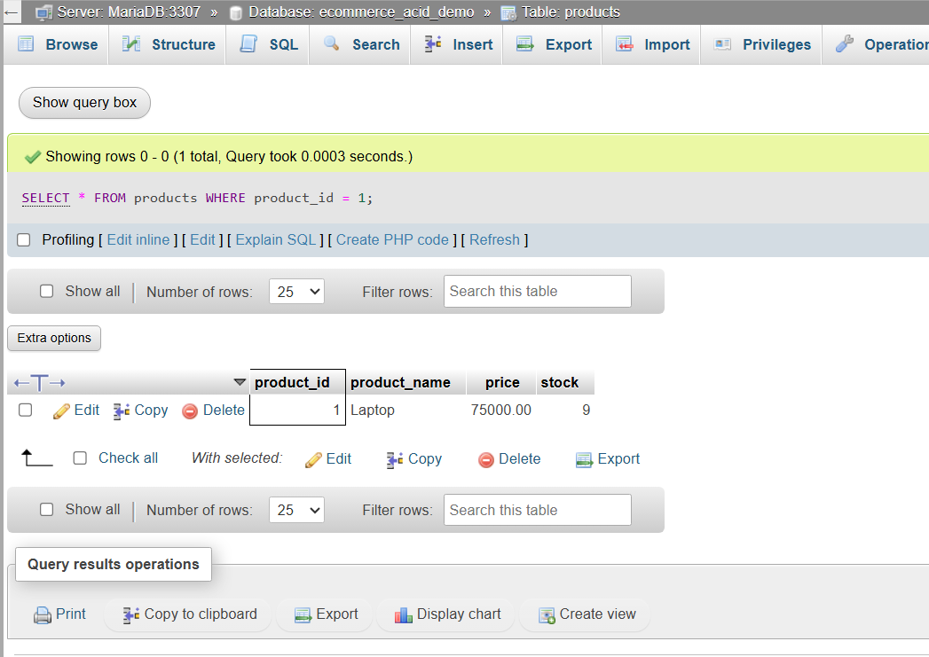
The transaction update became visible after commit. This demonstrates isolation between transactions.

4.4 Durability

4.4.1 Committing a Transaction
Durability means that once a transaction is committed, the data remains permanently saved.
A new order was inserted and committed.
START TRANSACTION;

INSERT INTO orders (customer_id, status)
VALUES (2, 'Confirmed');

INSERT INTO order_items (order_id, product_id, quantity)
VALUES (LAST_INSERT_ID(), 2, 2);

COMMIT;

4.4.2 Checking Committed Data
The committed data was checked using:

SELECT * FROM orders;
SELECT * FROM order_items;
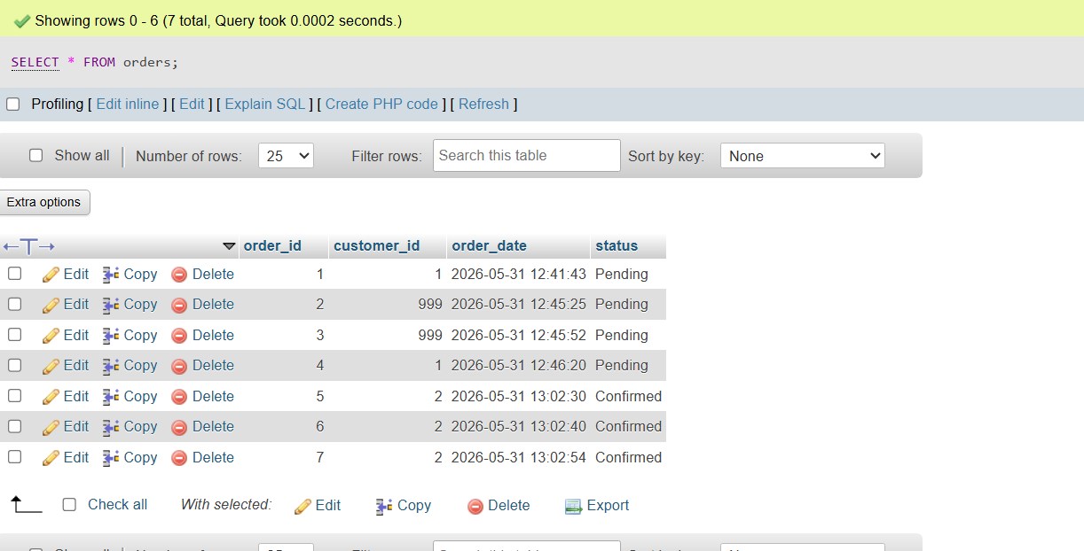
The committed data remained stored in the database. This demonstrates durability.

5. Result Summary
ACID Property | Demonstration
Atomicity | Inserted order was removed after rollback
Consistency | Invalid price and quantity were rejected
Isolation | Product stock update was handled through transaction sessions
Durability | Committed order remained saved in the database

Activity 3: Case Study Analysis
Distributed or cloud-based databases are needed to manage customers, restaurants, orders, payments, and dispatch tracking for online food delivery services such as Foodmandu, Pathao Food, Uber Eats, or DoorDash.
The application might be utilized simultaneously by thousands of people. Real-time restaurant searches, order placement, payment processing, and courier tracking are all available to clients. Delivery couriers update their locations, and eateries update the food they have available. The system may become unavailable or delayed during periods of high traffic if all of this data is stored in a single central database.
The system may manage multiple users, store data in different areas, enable speedier access, and continue even in the case of a server failure thanks to a distributed or cloud-based database.

Challenges Faced
The first concern is data consistency. The same order status might not change at the same time in every location since data might be stored on various servers. For example, an order might show up as "Out for Delivery" to one user and "Preparing" to another.
Another issue is network failure. Distributed databases require server-to-server connectivity. If there is a network difficulty, data synchronization may take longer.
Security and privacy are another key worry. The system stores client names, phone numbers, addresses, order histories, and payment details. If necessary, security safeguards are not followed, sensitive data may be exposed to unauthorized parties.
In addition, there is a lot of traffic on the system, particularly during lunch, dinner, festivals, and special deals. If too many people place orders at once, the database can become sluggish.

Another difficulty is backup and recovery. If data is lost due to a cyberattack, system breakdown, or accidental deletion, the organization needs to be able to swiftly restore it.

Recommended Solutions
To circumvent these challenges, the system can use data replication, which retains copies of data on multiple servers. In the event of a server failure, another server can continue to deliver services.
The system can also apply load balancing to spread user requests among multiple servers. This prevents the overloading of a single server.
Sharding allows for the splitting of enormous amounts of data into smaller portions. For example, order data can be sorted by city or area, which expedites searches and processing.
For security, the system should feature role-based access control, encryption, authorization, and authentication. Payment and personal information must be adequately protected.
The organization should also implement automatic backup and recovery techniques. In the event of a disaster, regular backups assist restore data.
Frequently accessed data, such as popular meals and restaurant menus, may be cached. This decreases database demand and speeds up applications.
Strong consistency should be used by the system for crucial data like order confirmation and payment. It is possible to apply eventual consistency to less significant data, such ratings or recommendations.
Concepts Applied
Concept | Application
Distributed Database | Data is stored across multiple servers
Cloud Database | Database is hosted on cloud for scalability
Replication | Copies of data are stored on different servers
Sharding | Large data is divided into smaller parts
Load Balancing | Requests are distributed across servers
Consistency | Correct order and payment status is maintained
Security | Customer and payment data is protected
Backup and Recovery | Lost data can be restored

